APPLICATION FOR ARTIST-DRIVEN PROJECTS
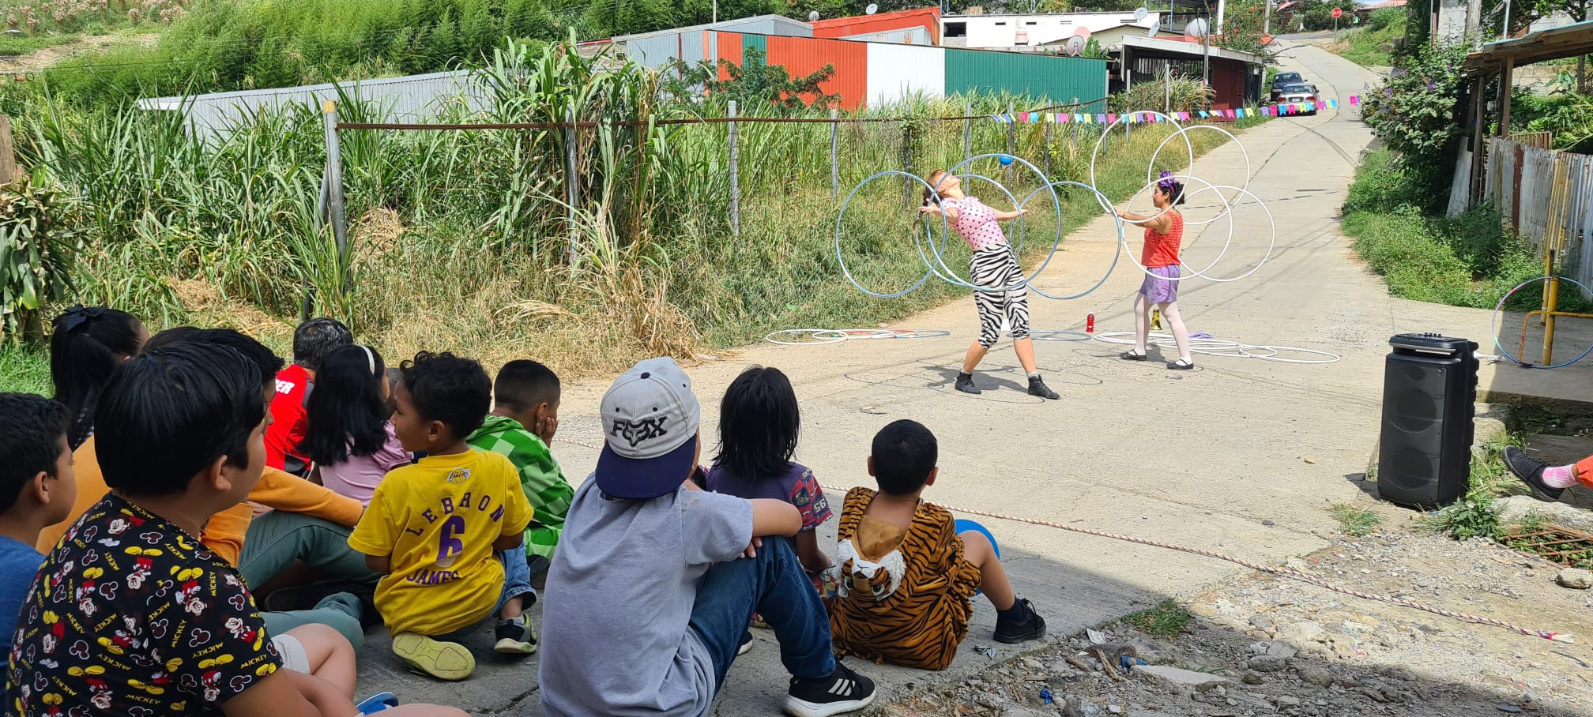
Do you have an idea for a project that could bring more hope, laughter, and dreams to children in vulnerable situations, and are eager to bring it to life? Develop the project you believe is most needed and apply for funding from Clowns Without Borders to make it happen. Here’s to more laughter in the world!
Artist-driven project in Costa Rica 2023
For several years, Clowns Without Borders has provided grants for artist-driven projects to its members. An artist-driven project requires significant independent work and initiative, and is a way for the organization to increase engagement and participation among our artists. If your project is approved, you will be responsible for the planning, execution, and reporting. The office will be available to provide support and feedback. To apply, you must be a member of Clowns Without Borders.
For projects taking place in 2026, you can apply for up to 75 000 SEK to cover costs such as fees (in line with Clowns Without Borders' guidelines), transport, food, accommodation, visas, and vaccinations. Clowns Without Borders also has sound equipment, props, materials, and first aid kits available to borrow, depending on availability.
What type of project can you apply for?
Performance tours, educational missions, or even training for adults working with children. Short-term efforts or long-term projects—it's your project, so think freely. The most important thing is that the project is meaningful for the target group—vulnerable children—and contributes to the goal of spreading more laughter, hope, and dreams.

Things to keep in mind:
- You must have been a member for at least one year to apply.
- You must have participated in previous assignments with Clowns Without Borders.
- The project must be completed and reported before December 2026.
- You should have a partner organization and a clear idea of how to reach your target group.
- It is advantageous to have other funders besides Clowns Without Borders, and these projects will be prioritized.
- The application must include a complete budget.

Application Process
Options:
- TEXT: Save a copy of this document and fill out the application on your computer. Name the document with the same name as the project (or a shortened version).
- VIDEO: Film yourself/your group answering the application questions.

Email your application to: Kajsa Englund (kajsa.englund@clownerutangranser.se) or Farhad Mazi Esfahani at (farhad.mazi@clownerutangranser.se).

Application deadline: Sunday, december 15, 2025.

Decision Process
Applications will be reviewed by a specially appointed working group. The group will evaluate the quality of the application, the feasibility of the project, the needs of the target group, and the project's relevance to Clowns Without Borders’ mission. Decisions are final, and individual feedback will not be provided.
Results will be communicated in February 2026.
Please note that Clowns Without Borders is not a traditional grant-giving organization. Funding artist-driven projects is a unique opportunity we offer to increase engagement among members and reach new groups of children we may not have otherwise been able to reach.

Questions?
Contact Kajsa Englund at (kajsa.englund@clownerutangranser.se) or Farhad Mazi Esfahani at (farhad.mazi@clownerutangranser.se).

1. Project

Project name | Date of application
Applicant artist/ensemble: | Project country:

2. Formal Details
2.1 Contact Information
2.2 Information about the applying ensemble
Project Manager: | Number of members
Address | Name of member 1 | Name of member 2
Address | Name of member 3
E-mail of project manager | Name of member 4 | Name of member 5
Phone number of project manager

3. Timeline
Estimated project start date: | Estimated project end date: | Number of days (excluding travel days):

4. Background and Goals
Describe the situation or problem that a Clowns Without Borders intervention could positively impact. What is the overarching goal of the intervention?

Target group (number of people, age group, gender distribution):

5. Activities
Describe the planned activities (e.g., performances, educational interventions, Training of Trainers, etc.). If possible, provide a schedule.

6. Partners
Which organizations or local artists working in the area/with the target group could Clowns Without Borders collaborate with to carry out the described activities?

7. Monitoring and Evaluation
How will the project be documented/monitored on an ongoing basis?

How will the results of the intervention be evaluated after completion?

8. Risk analysis
What risks to the project’s implementation have you identified?

How will you minimize the identified risks?

9. Budget
List all project costs here.
Example budget items (adjust as needed) | Number | Total in SEK
Travel (including visas, vaccinations, etc.)
Local travel
Food
Accommodation
Fees
Other
 | TOTAL
 | Requested from Clowns without Borders Sweden
 | Other funding:
 | Personal contribution (e.g., volunteer time):

Thank you for your application!

